Herbal / Unani Product Catalog
Categorized by Health Use

Sexual Health & Reproductive Tonics
Qarshi Shahi Capsule
Rs 400
Brand: Qarshi
Size: 10 Capsules
Use: Aphrodisiac; specific medicine for sexual and nervine weakness, spermatorrhoea, and nocturnal emission; potentiates the functioning of vital organs.
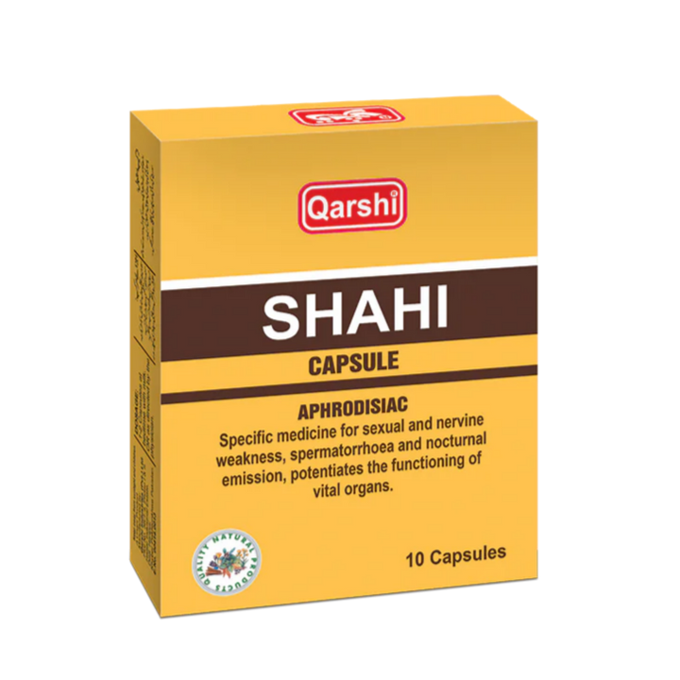

Majoons
Qarshi Laboob Khas Jawahar Wala
Rs 500
Brand: Qarshi
Size: —
Use: Unani formulation traditionally used as a general sexual/vitality tonic (jawahar-based).
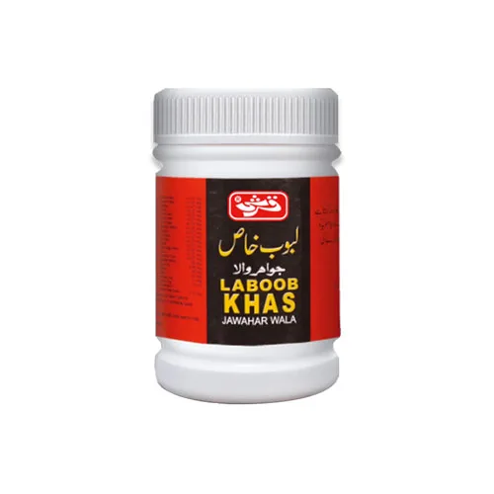

Qarshi Majoon Ard Khurma
Rs 220
Brand: Qarshi
Size: 100 gm
Use: Effective in spermatorrhoea and premature ejaculation.
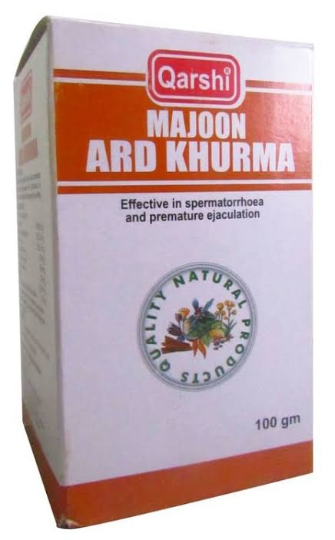

Hamdard Majun Filasfa
Rs 230
Brand: Hamdard
Size: 100 gm
Use: Stimulates production of semen and increases sexual power; tones the bladder, stops micturition issues; relieves backache; also a digestive.
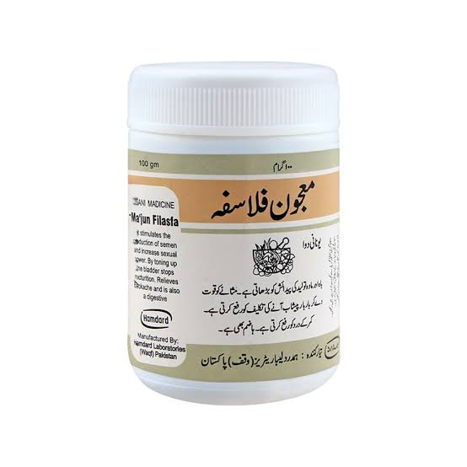

Qarshi Majoon Mughaliz Jawahar Wali
Rs 550
Brand: Qarshi
Size: —
Use: Unani formulation used as a sexual tonic/vigor enhancer (jawahar-based).
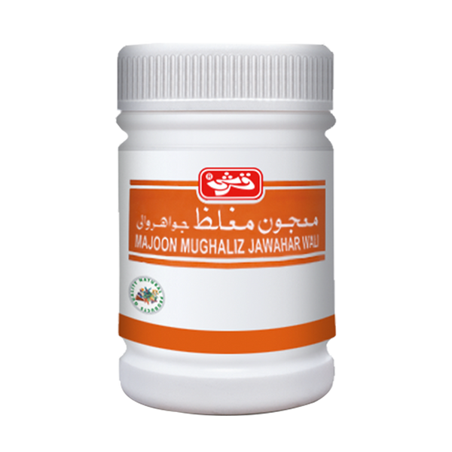

Blood Purifier & Skin Care
Hamdard Ma'jun Ushba
Rs 300
Brand: Hamdard
Size: 100 gm
Use: Blood purifier; effective remedy for syphilis, eczema, and other skin eruptions due to waste metabolites in blood; also useful in gout.
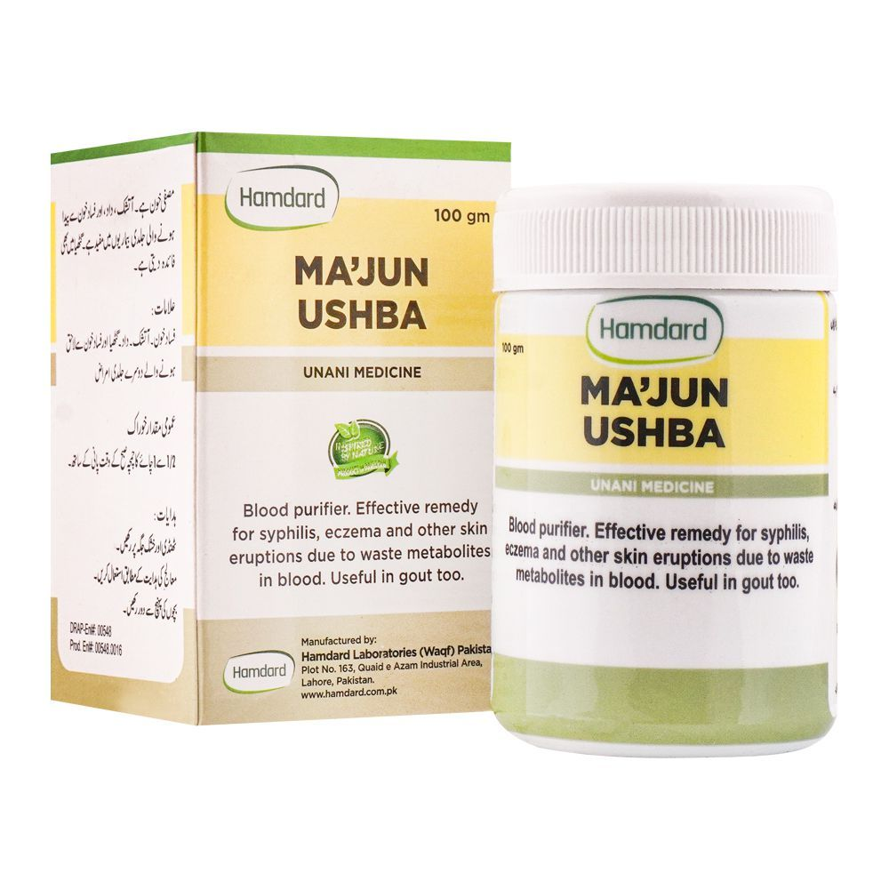

Brain & Nervous System Tonics
Qarshi Demaghi
Rs 290
Brand: Qarshi
Size: 50 gm
Use: Tonic for the brain and nerves ("Demagh aur Asaab kay liye mufeed tonic").
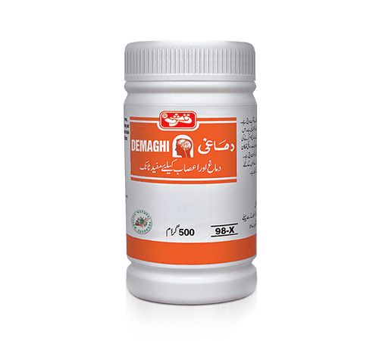

Digestive Aids
Qarshi Jawarish Shahi
Rs 240
Brand: Qarshi
Size: —
Use: Unani digestive formulation (Jawarish) for stomach and digestion support.
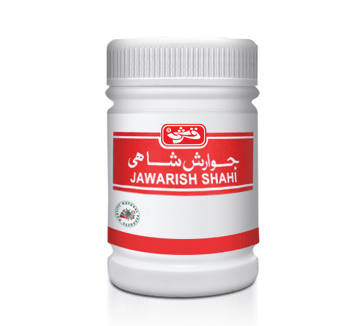

Syrups
Qarshi Gestofill Liquid
Rs 160
Brand: Qarshi
Size: 120 ml
Use: Digestive/intestinal liquid tonic.
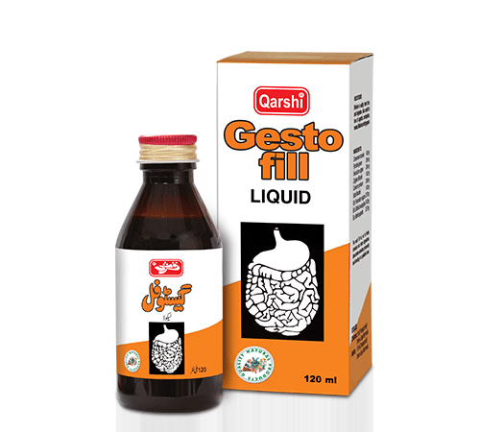

Blood/Iron Tonics & General Weakness
Qarshi Sharbat Faulad
Rs 250
Brand: Qarshi
Size: 240 ml
Use: Iron-based tonic for blood deficiency and general weakness.
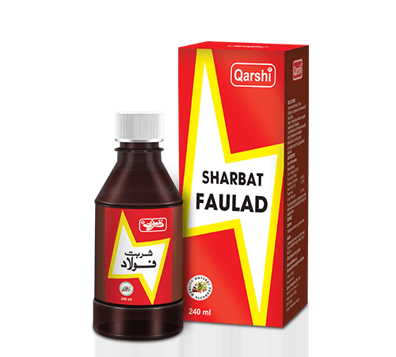

Qarshi Fauladi Tonic
Rs 200
Brand: Qarshi
Size: 240 ml
Use: Excellent tonic for blood deficiency and general weakness.
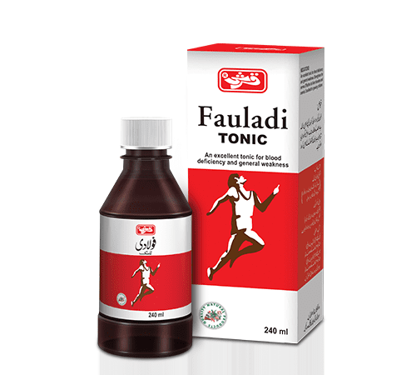

Children's Health & Growth Tonics
BMA Vigurine Children Syrup
Rs 110
Brand: BMA
Size: —
Use: For better health and growth of babies; Unani medicine.
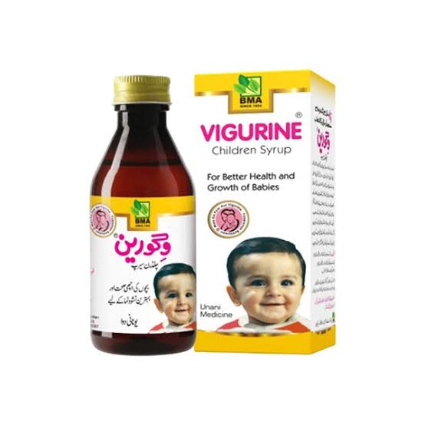

Qarshi Tone Up Tonic
Rs 160
Brand: Qarshi
Size: 120 ml
Use: Excellent tonic for children.
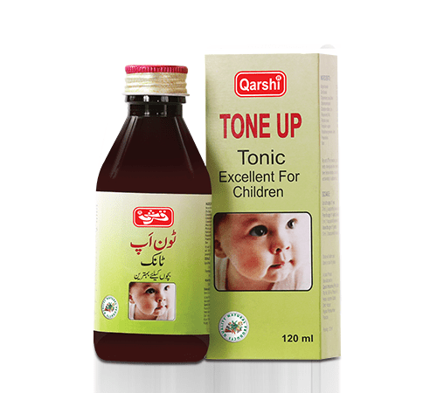

Qarshi Sada Bahar
Rs 170
Brand: Qarshi
Size: 120 ml
Use: Excellent tonic for children.
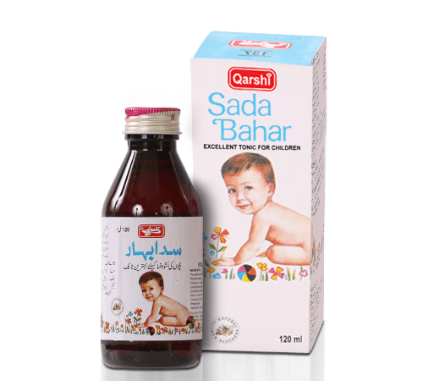

Fever & Infection Relief
Qarshi Typhex Plus
Rs 170
Brand: Qarshi
Size: 60 ml
Use: Used for typhoid-type fever symptoms.
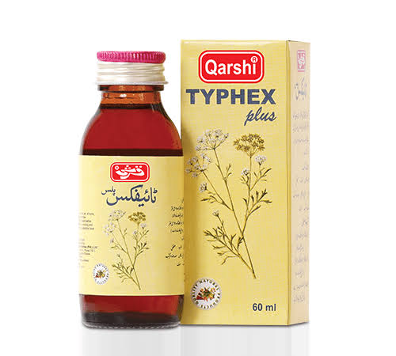

Qarshi Fever-X (Taryaq Bukhar)
Rs 160
Brand: Qarshi
Size: 120 ml
Use: Antidote/remedy for fever (Taryaq Bukhar).
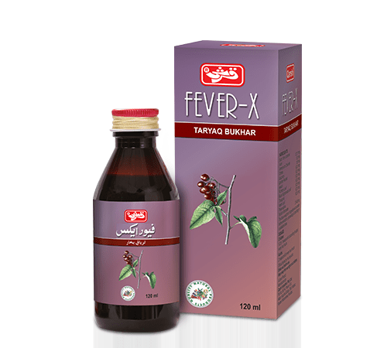

Respiratory, Cough & Lung Care
Qarshi Lal Sharbat
Rs 190
Brand: Qarshi
Size: 240 ml
Use: Expectorant, vasodilator, decongestant, antihistaminic, antitussive.
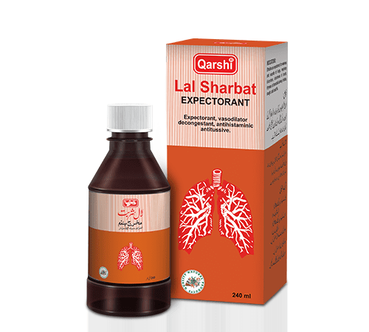

Ajmal Sharbat Sadar
Rs 160
Brand: Ajmal
Size: 140 ml
Use: For colds, coughs, and phlegm; cough syrup for the chest/lungs.
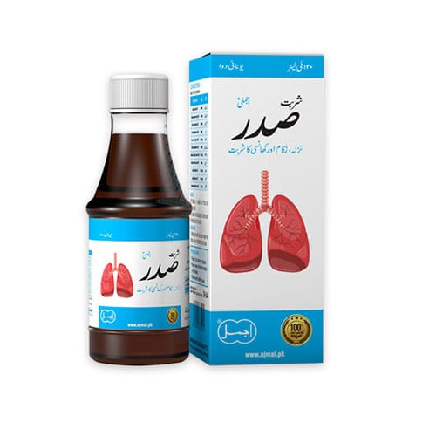

Qarshi Sharbat Sadar
Rs 190
Brand: Qarshi
Size: 120 ml
Use: Effective medicine for problems associated with the lungs.
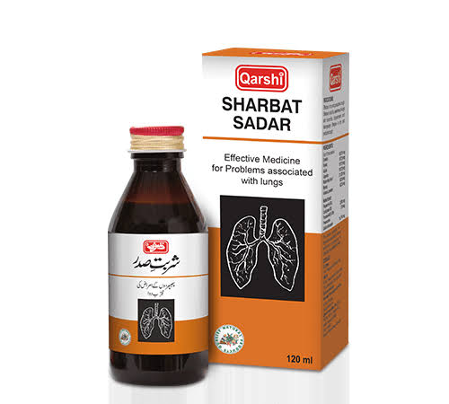

Qarshi Asthmina
Rs 220
Brand: Qarshi
Size: 120 ml
Use: Formulated for asthma and lung-related respiratory support.
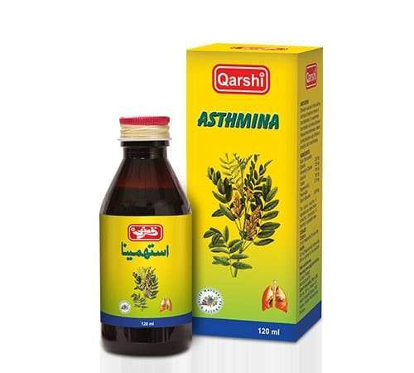

Hamdard Infuza
Rs 180
Brand: Hamdard
Size: 120 ml
Use: Effective herbal formulation for the relief of cold & flu symptoms.


Sharbat & Arq Preparations

Sharbat Jaam-e-Shireen
Rs 550
Brand: Aftab Qudrati
Size: —
Use: Traditional cooling and refreshing Unani sharbat.
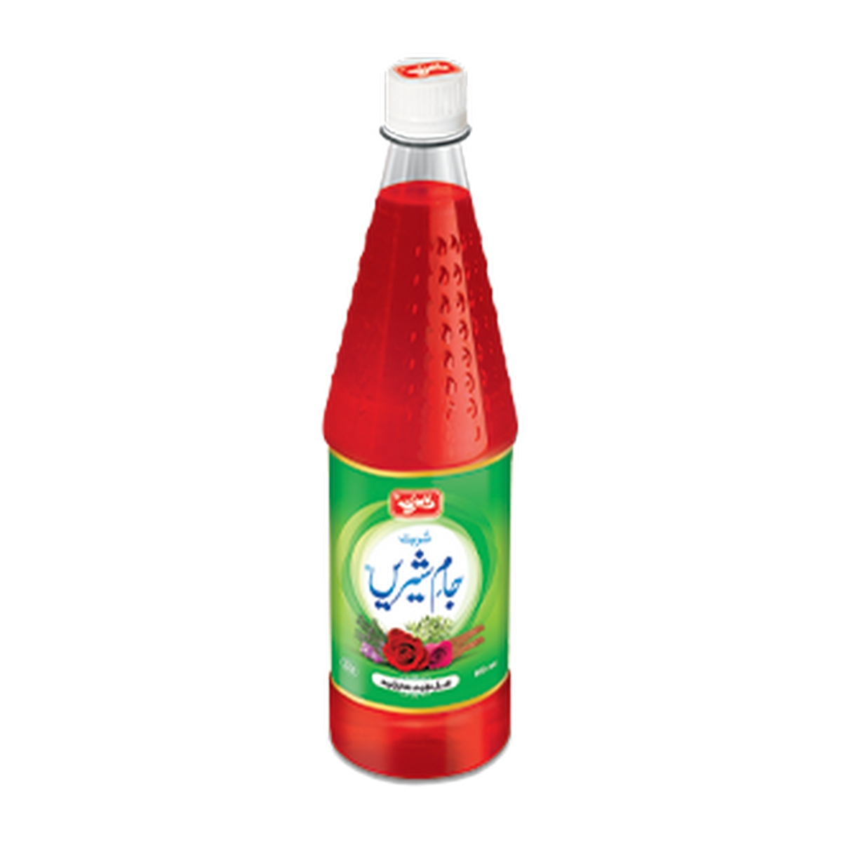

Sharbat Sandal Classic
Rs 500
Brand: Aftab Qudrati
Size: —
Use: Sandalwood-based cooling sharbat used to relieve burning sensation and heat exhaustion.
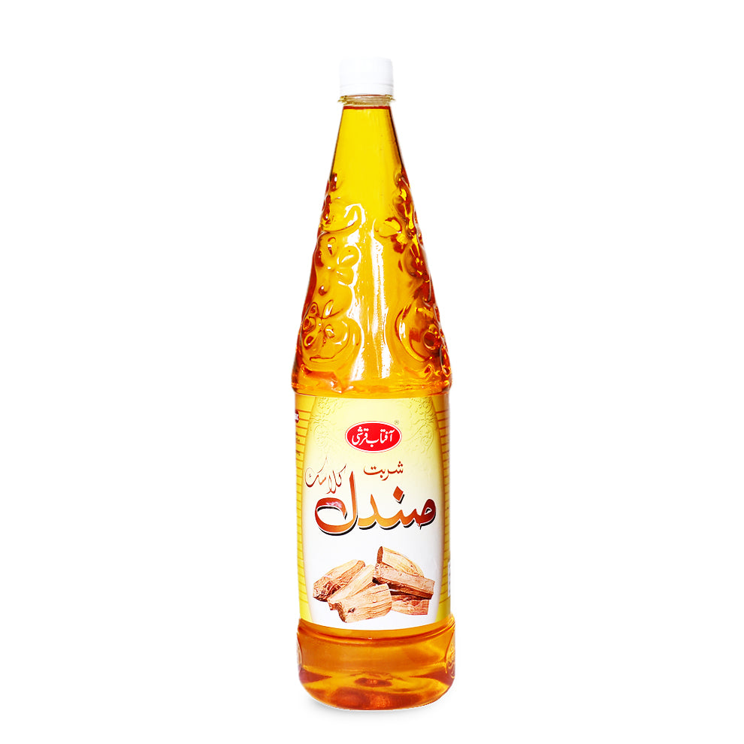

Sharbat Anjbar
Rs 450
Brand: —
Size: —
Use: Unani sharbat for medicinal use on prescription (as advised by a Hakim).
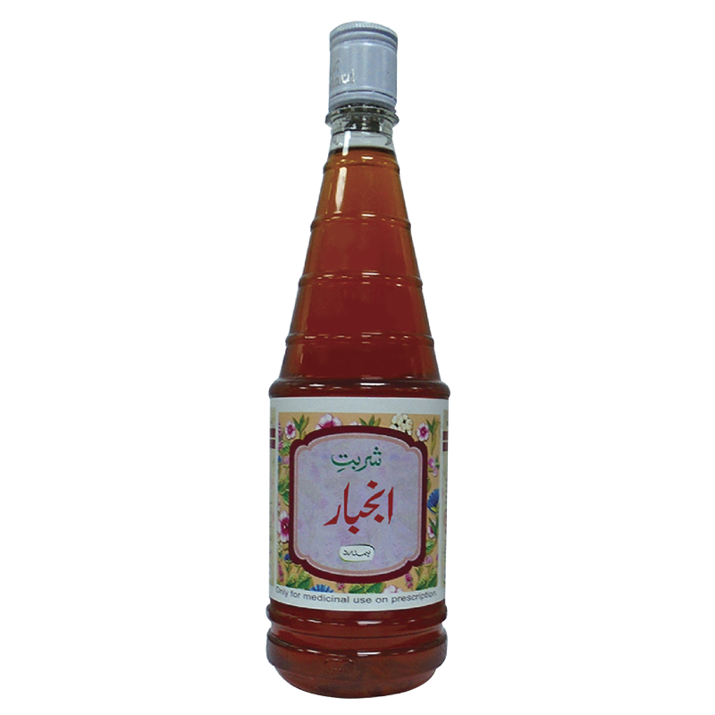

Sharbat Buzoori Motadil
Rs 500
Brand: Hamdard
Size: —
Use: Traditionally used as a cardiac and brain tonic; for medicinal use on prescription.
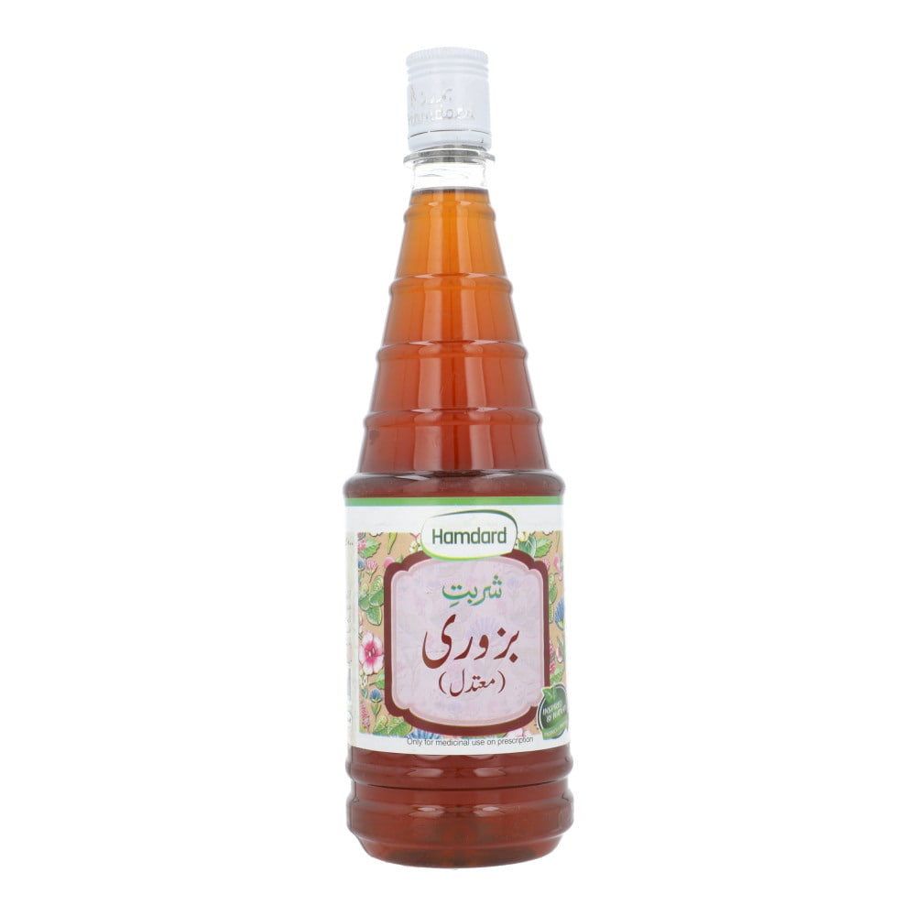

Arq (Distillates)
Arq Gulab Khas
Rs 285
Brand: Qarshi
Size: —
Use: 100% natural pure rose water; used as a soothing skin/eye toner and flavoring agent.
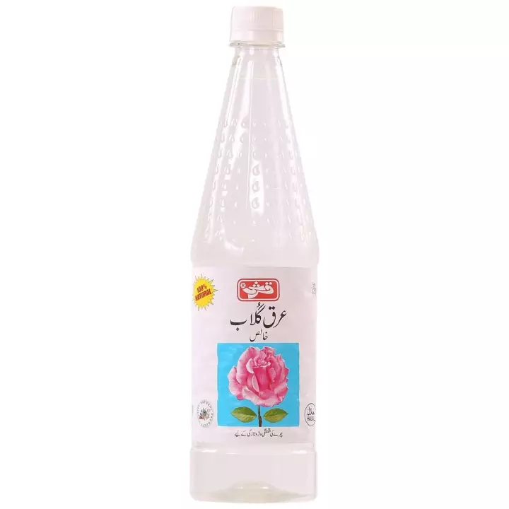

Arq Gaozaban
Rs 240
Brand: Aftab Qudrati
Size: —
Use: Tonic for the heart and brain ("Muqawwi Dil-o-Dimagh").
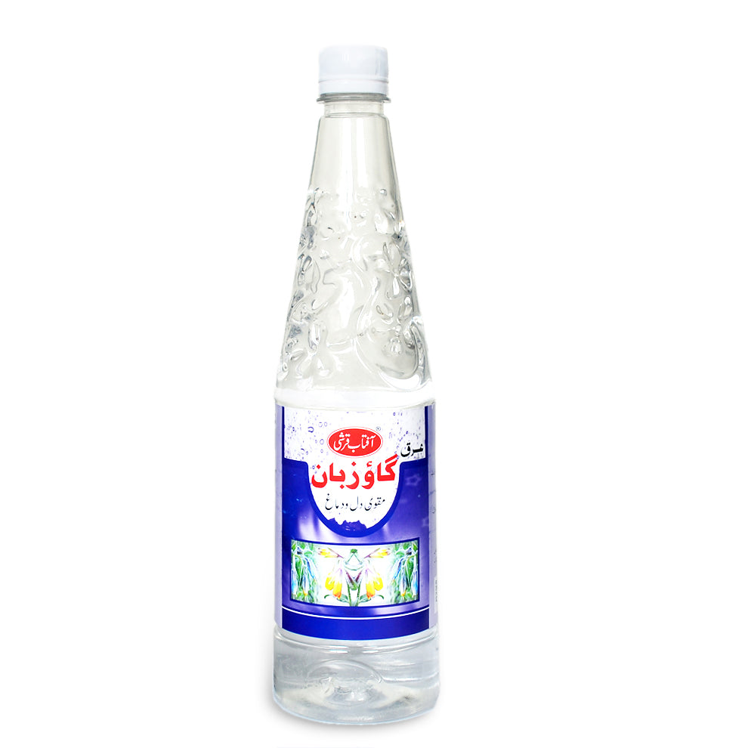

Arq Kasni
Rs 240
Brand: Aftab Qudrati
Size: —
Use: Beneficial for the liver and kidneys.
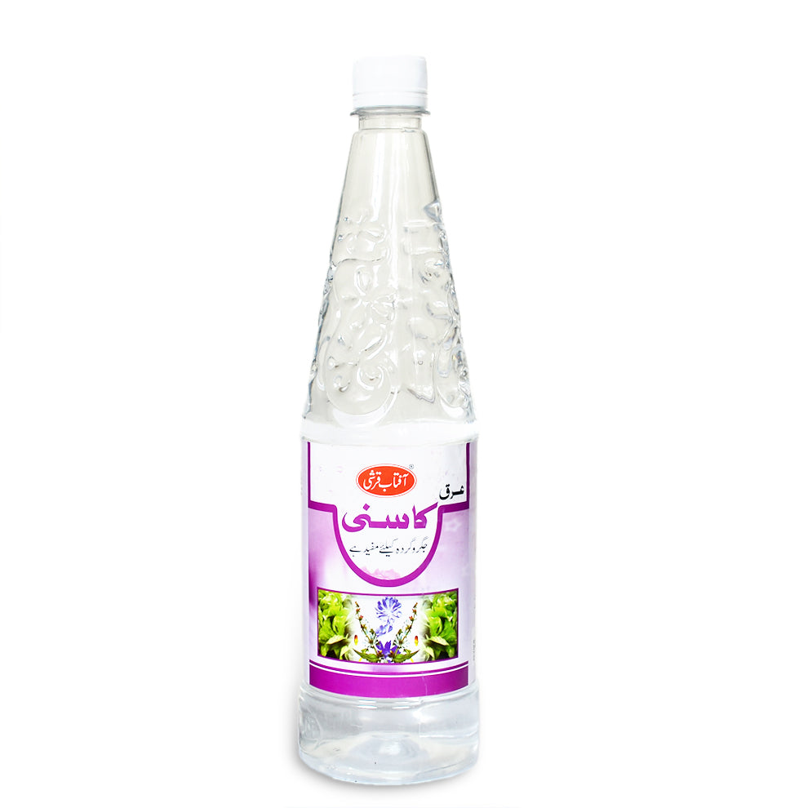

Arq Podina
Rs 220
Brand: Aftab Qudrati
Size: —
Use: Mint distillate; aids digestion and relieves stomach discomfort.
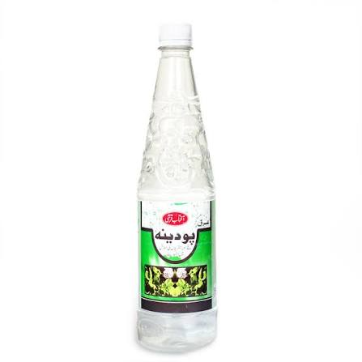

Arq Panchgul (Cho Arqa)
Rs 240
Brand: Aftab Qudrati
Size: —
Use: Tonic for the stomach and heart ("Muqawwi Meda-o-Qalb"); made from a blend of ingredients.
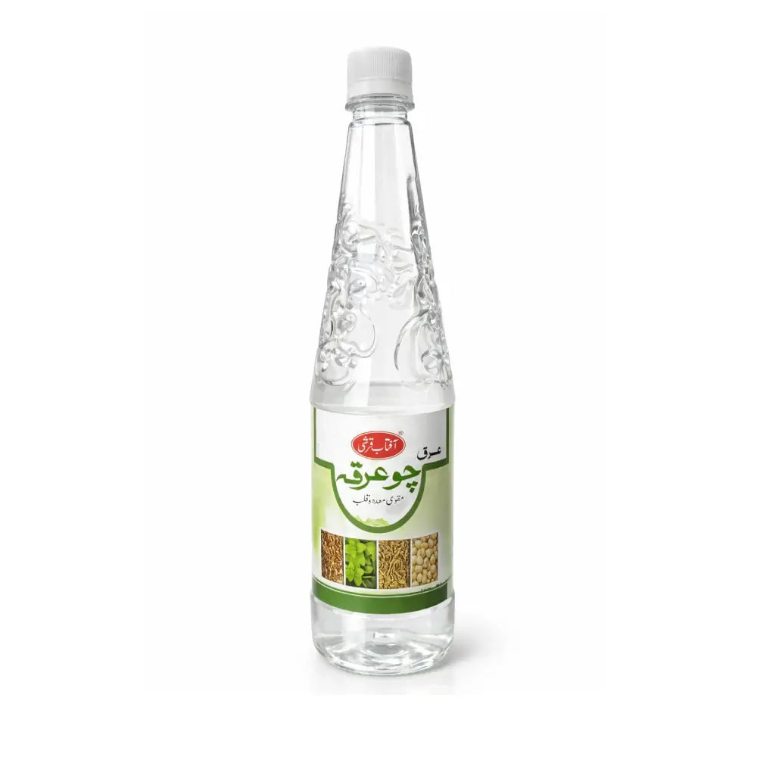

Qarshi Arq Shirin
Rs 130
Brand: Qarshi
Size: 240 ml
Use: Natural gripe water; regulates the digestive system of infants.
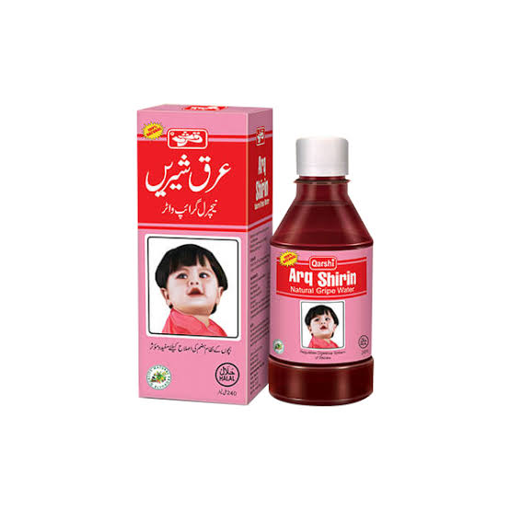

Murabba (Candied Fruit Preserves)
Murabba Amla
Rs 800/ kg
Brand: —
Size: —
Use: Indian gooseberry preserved in sugar syrup; traditionally used as a rejuvenative tonic, rich in Vitamin C, supports digestion and immunity.
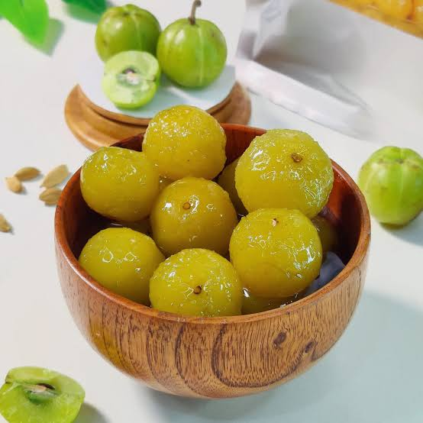

Murabba carrot
Rs 600/ kg
Brand: —
Size: —
Use: Ginger preserve in sugar syrup; traditionally used to aid digestion and relieve nausea and cold symptoms.
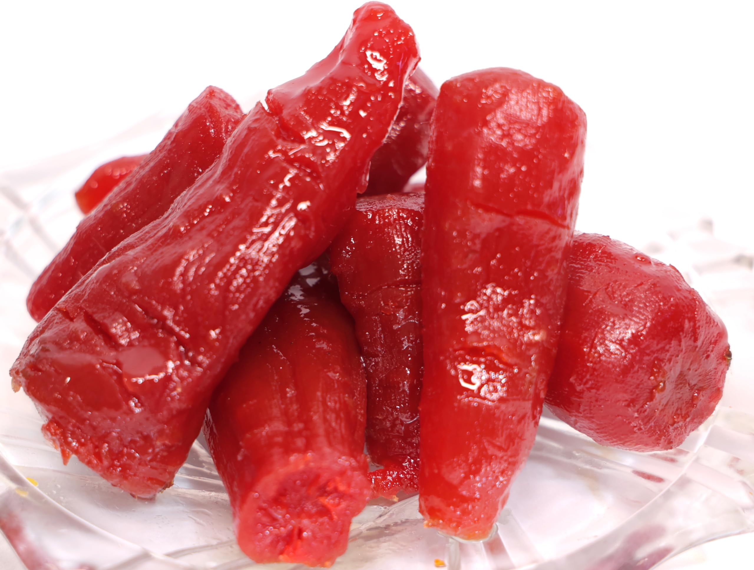

Murabba Apple
Rs 800/ kg
Brand: —
Size: —
Use: Beleric myrobalan preserve in syrup; traditionally used to support respiratory and digestive health.
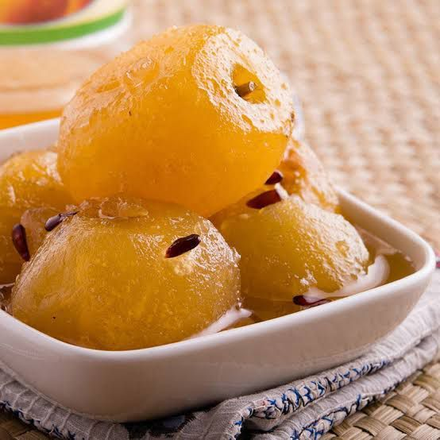

Murabba Harar
Rs 1200/ kg
Brand: —
Size: —
Use: Chebulic myrobalan preserve in syrup; traditionally used as a digestive tonic and mild laxative.
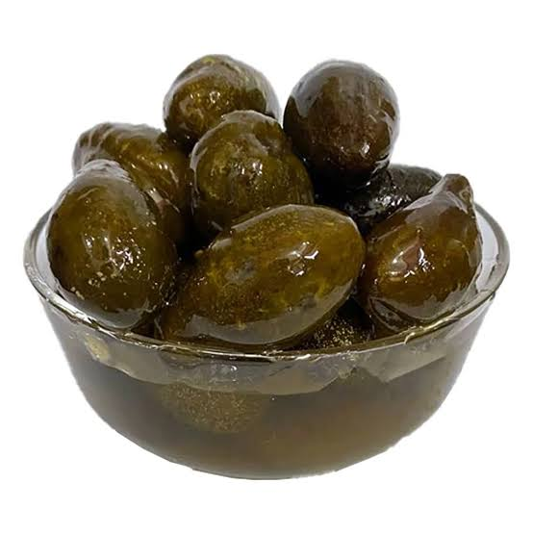

Allu Bukhara
Rs 400/ 250g
Brand: —
Size: —
Use: Apricot preserve in syrup; traditionally used as a general tonic and digestive aid.
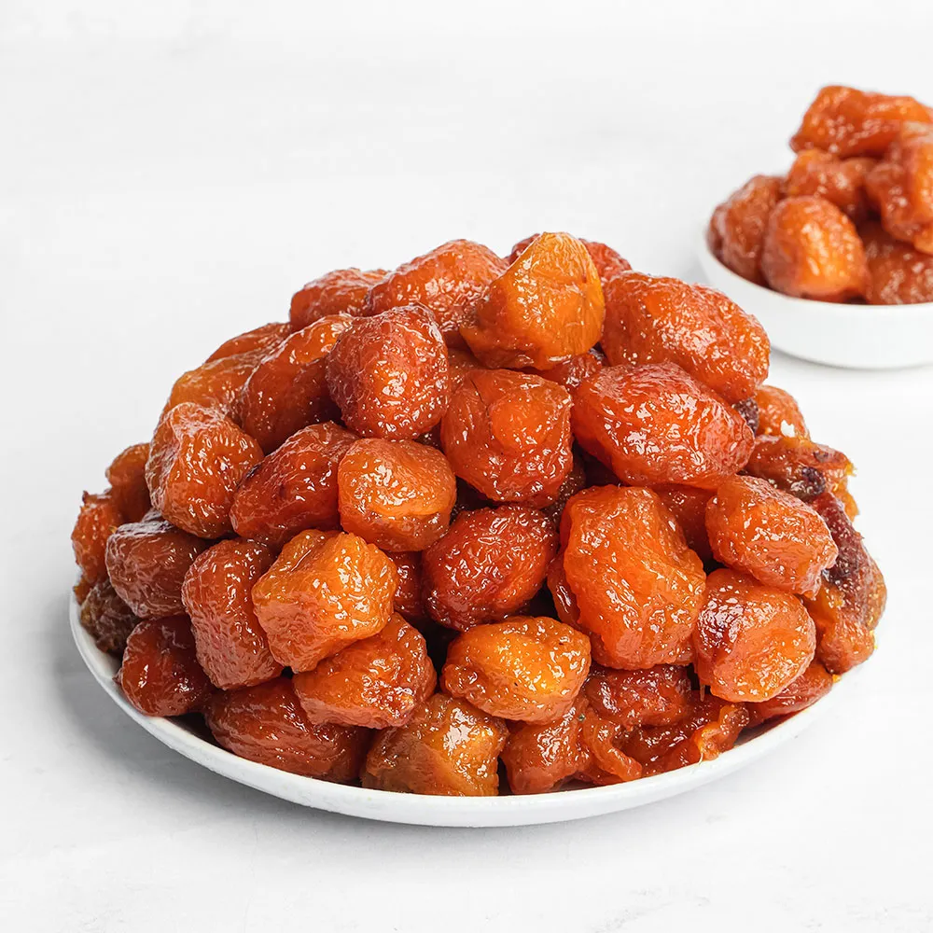

Spices & Condiments
Mixed Vegetable Pickle (Achaar)
Rs 400/ kg
Brand: —
Size: —
Use: Traditional spiced and oil-based mixed vegetable pickle used as a condiment and appetite stimulant.
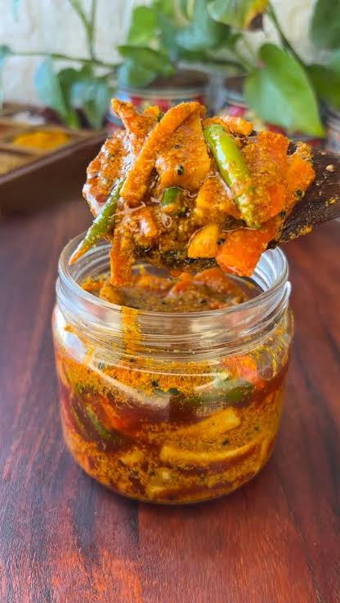

Red Chilli Powder
Rs 700/ kg
Rs 350/ half kg
Brand: —
Size: —
Use: Ground dried red chillies; used as a spice for flavor and heat in cooking.
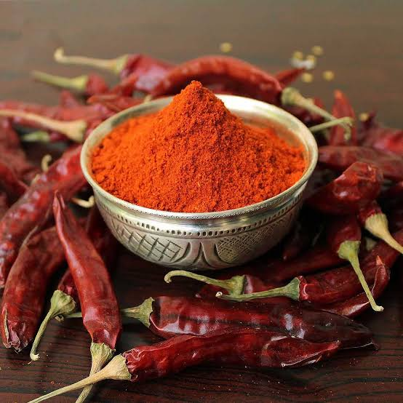

Turmeric Powder
Rs 350/ half kg
Brand: —
Size: —
Use: Ground turmeric root; used as a spice with traditional anti-inflammatory and antiseptic properties.
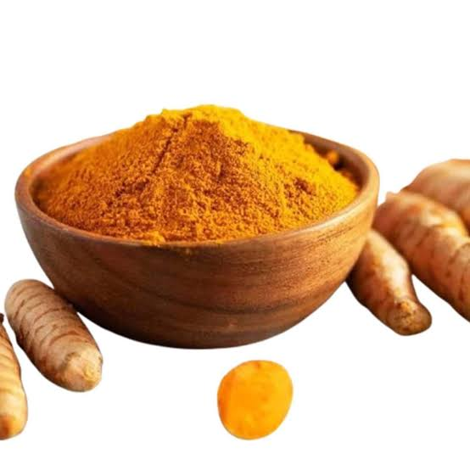

Black Pepper (Whole & Ground)
Rs 2400/ kg
Rs 600/ 250g
Brand: —
Size: —
Use: Whole peppercorns and ground pepper; used as a spice, aids digestion and adds warmth to dishes.
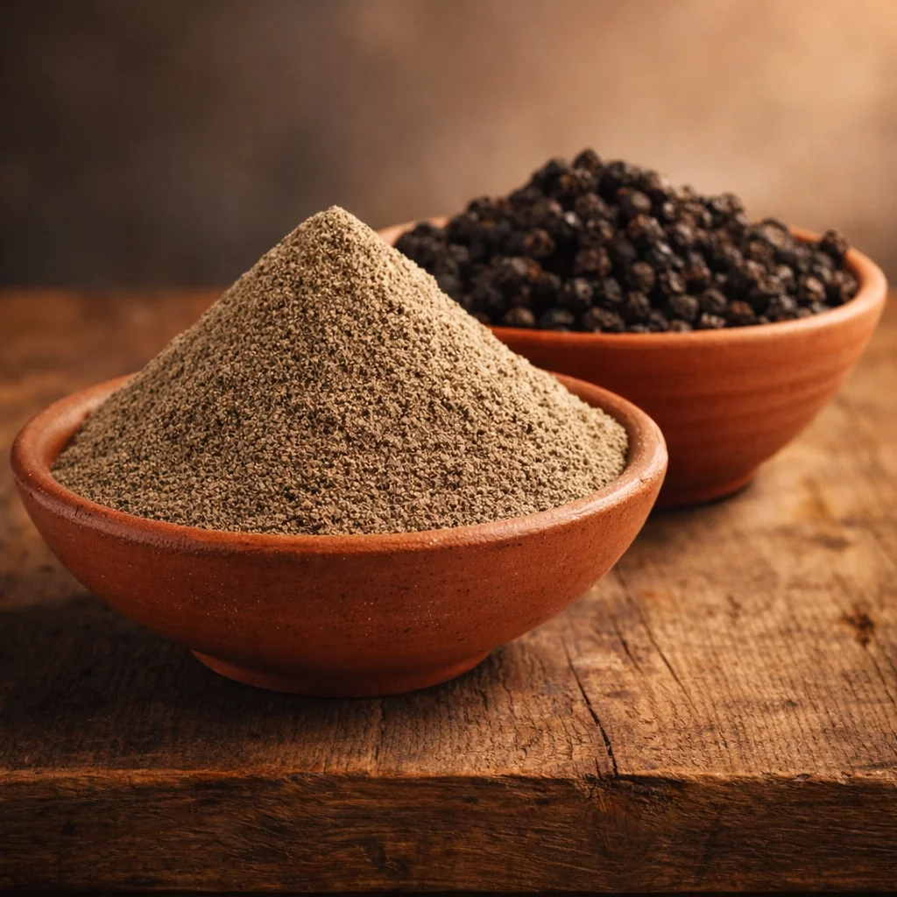

Cinnamon (Dalchini)
Rs 250/ 250g
Brand: —
Size: —
Use: Dried cinnamon bark; used as a spice with traditional digestive and warming properties.
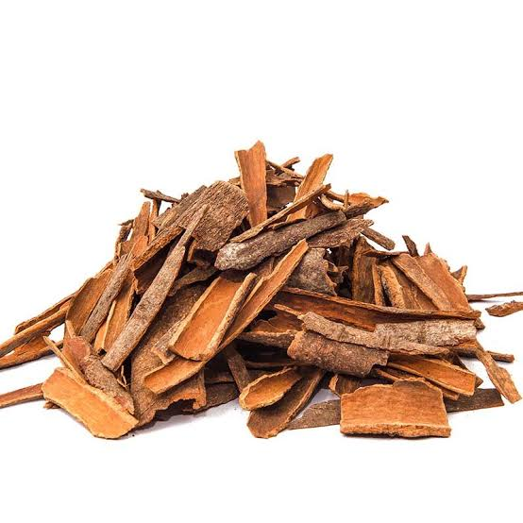

Kalonji (Nigella Seeds)
Rs 250/ 250g
Brand: —
Size: —
Use: Black seeds used as a spice and traditional remedy for digestive and immune support.
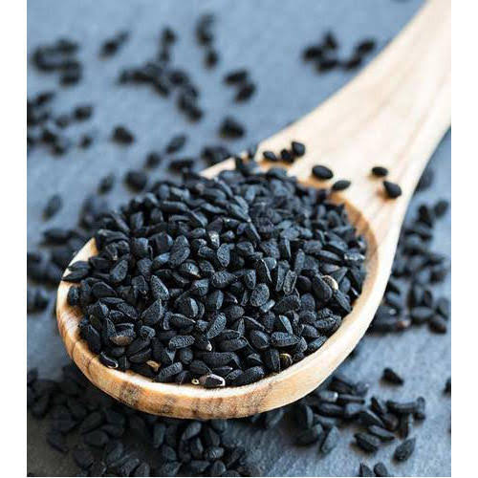

Cumin Seeds (Zeera)
Rs 300/ 250g
Brand: —
Size: —
Use: Whole cumin seeds; used as a spice to aid digestion and flavor dishes.
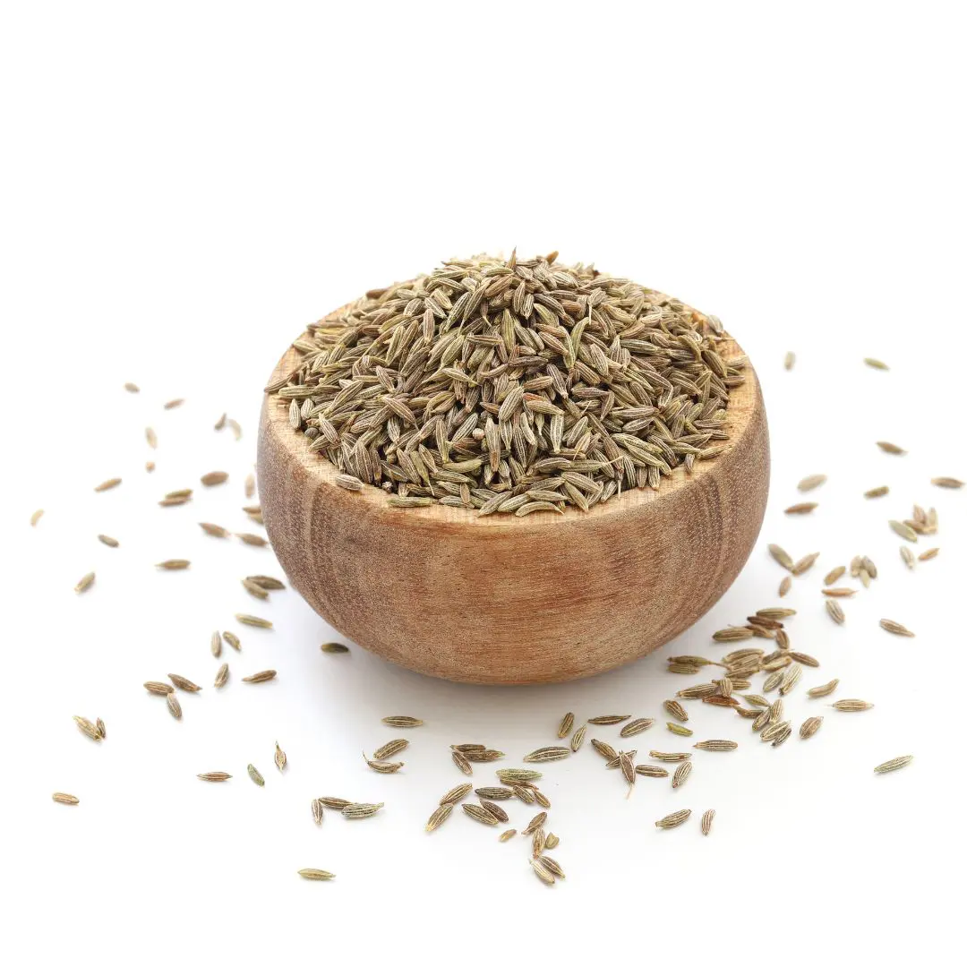

Fennel Seeds (Saunf)
Rs 200/ 250g
Brand: —
Size: —
Use: Aromatic seeds used as a spice and digestive aid; also used as a mouth freshener.
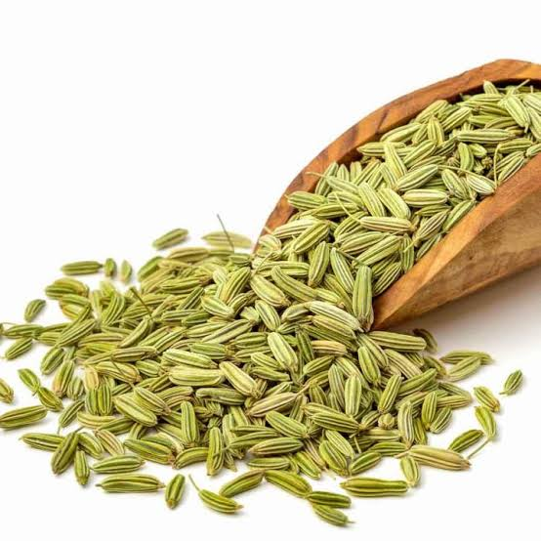

Tamarind (Imli)
Rs 120/ 250g
Brand: —
Size: —
Use: Tangy fruit pulp used as a souring spice/condiment in cooking; also used traditionally to aid digestion.
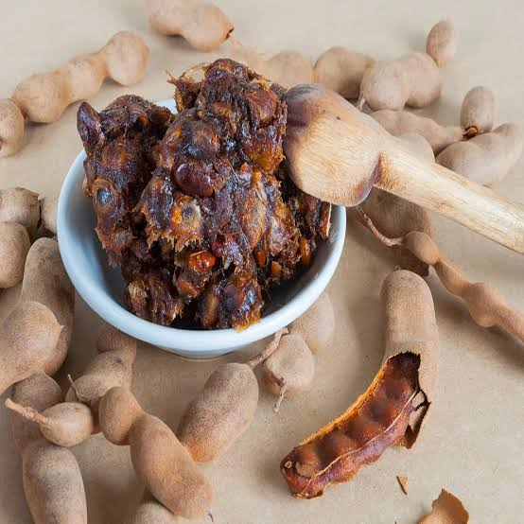

Dry Fruits & Nuts
Black Raisins (Kali Kishmish)
Rs 350/ 250g
Brand: —
Size: —
Use: Dried black grapes; traditionally used as a blood-builder and mild laxative, eaten as a snack or added to desserts.
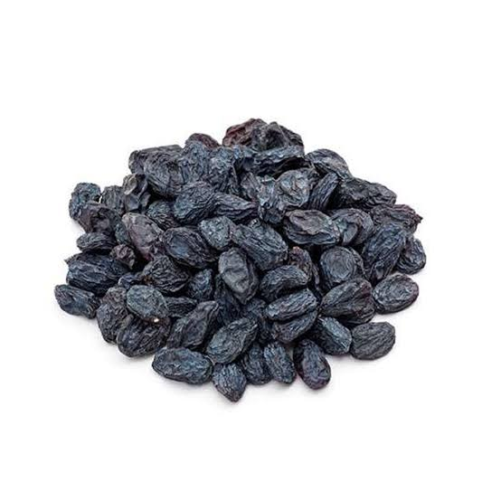

Golden Raisins (Kishmish)
Rs 300/ 250g
Brand: —
Size: —
Use: Dried golden grapes; a natural energy-boosting snack, also used in cooking and traditional tonics.
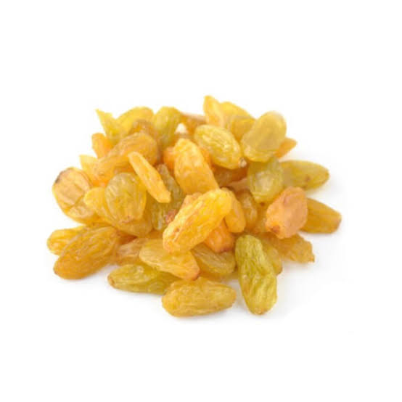

Roasted Chickpeas (Bhuna Chana)
Rs 520/ kg
Brand: —
Size: —
Use: Roasted split gram; a protein-rich traditional snack, also used in home remedies for digestion.
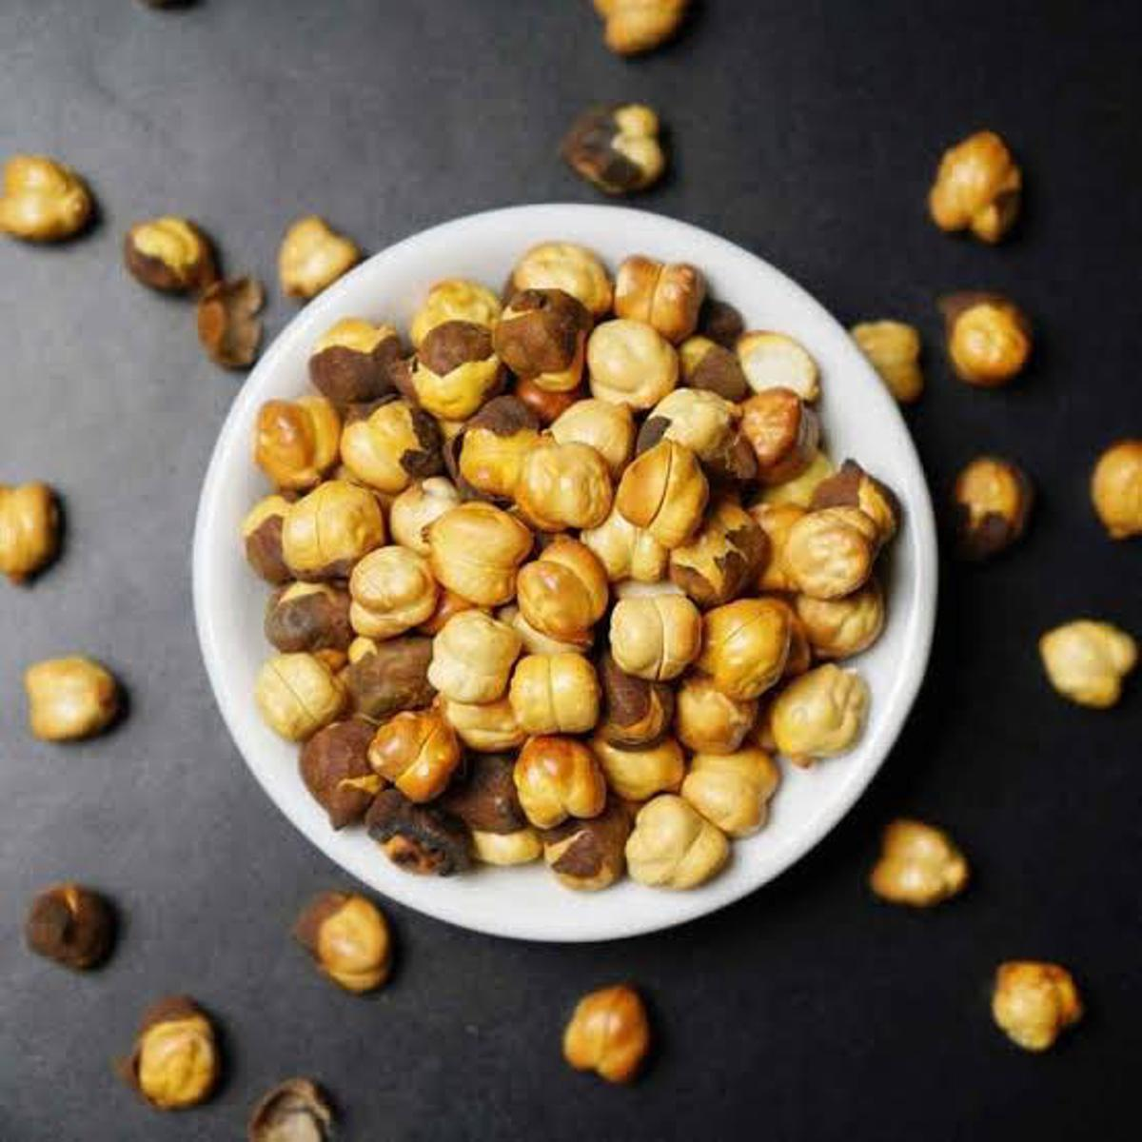

Coconut (Nariyal)
Rs 400/ 250g
Brand: —
Size: —
Use: Fresh coconut; used as food, in traditional remedies, and as a base for hair/skin oils.
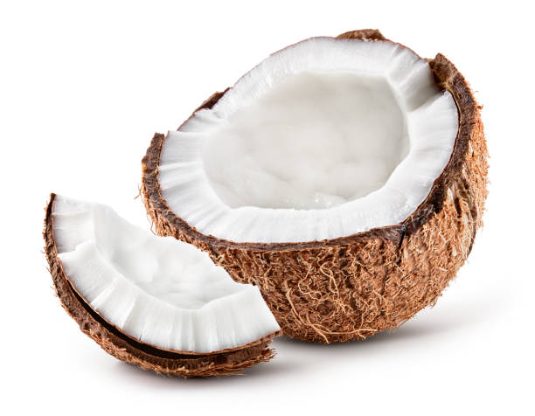

Cashew Nuts (Kaju) — Raw
Rs 850/ 250g
Brand: —
Size: —
Use: Raw cashew kernels; a nutrient-dense snack nut, also used in cooking and traditional tonics.
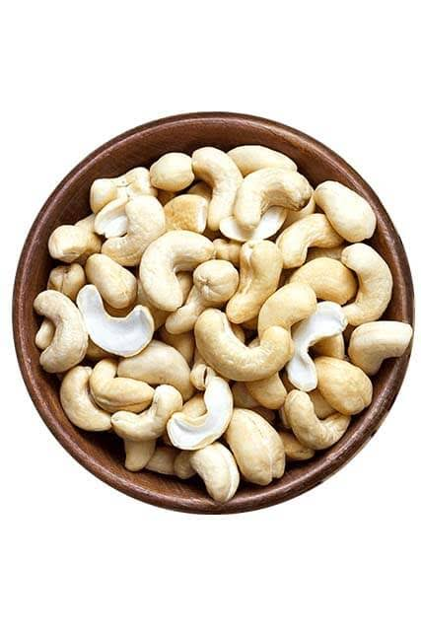

Cashew Nuts (Kaju) — Roasted
Rs 850/ 250g
Brand: —
Size: —
Use: Roasted cashew kernels; a popular energy-rich snack nut.
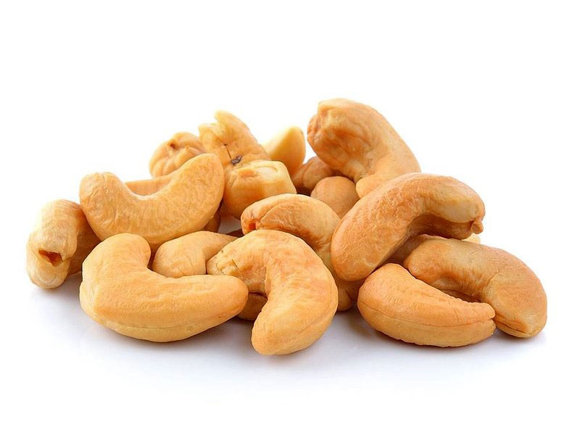

Walnuts (Akhrot)
Rs 700/ 250g
Brand: —
Size: —
Use: Shelled walnut kernels; traditionally regarded as a brain tonic, rich in healthy fats.
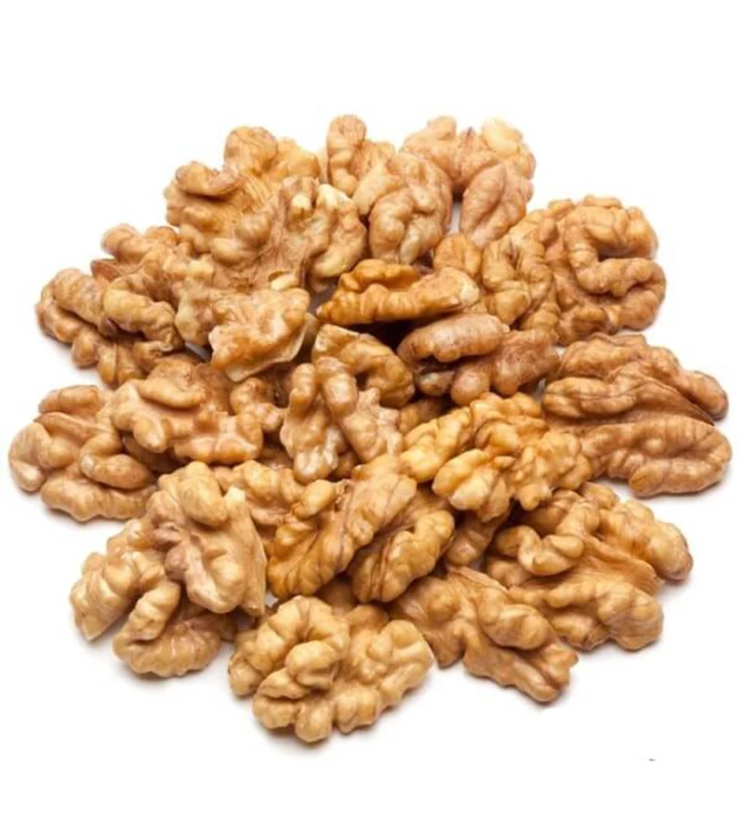

Almonds (Desi Badam) —
Rs 750/ 250g
Brand: —
Size: —
Use: Whole almonds; a traditional brain and general health tonic, eaten daily as a nutrient-dense snack.
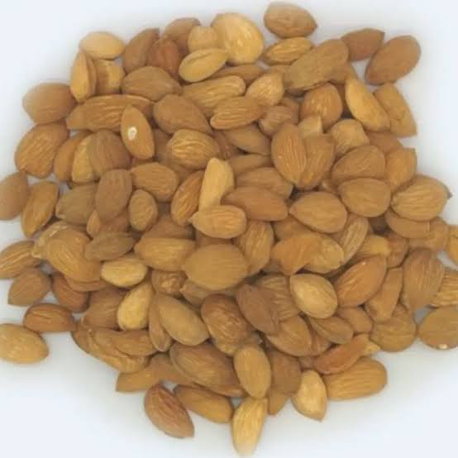

Almonds (Badam) — American/ Irani
Rs 800/250g
Brand: —
Size: —
Use: Smaller, richer-flavored almond variety; used the same way as regular almonds in traditional diets.
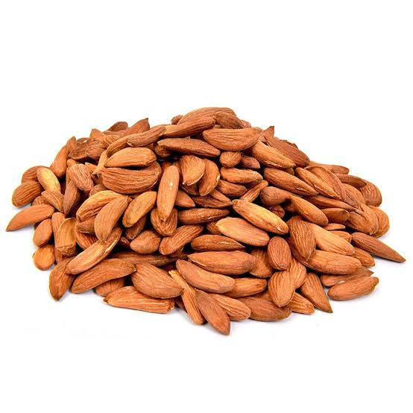

Herbs & Medicinal Roots
Saffron (Kesar/Zafran)
Rs 450/ 1g
Brand: —
Size: —
Use: Prized aromatic herb; used in small amounts as a mood, skin, and general wellness tonic, and as a natural food colorant/flavoring.
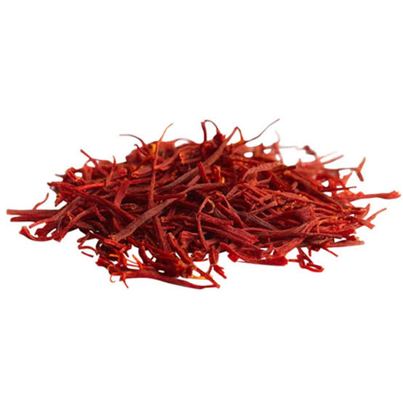

Salab Misri (Salep Root)
Rs 650/ 10g
Brand: —
Size: —
Use: Dried orchid tuber; a classical Unani general and reproductive-health tonic.
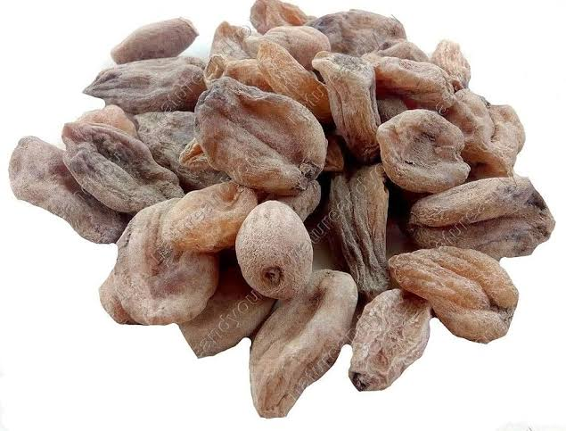

Salab punja
Rs 500/ 10g
Brand: —
Size: —
Use: Dried fruit of the Gokshura plant; traditionally used to support urinary and reproductive health.
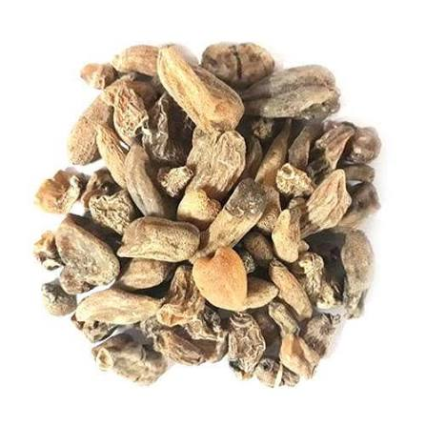

Raig Mahi (Sand Fish)
Rs 1500/ 10g
Brand: —
Size: —
Use: Traditional nervine tonic and aphrodisiac used in Unani medicine.
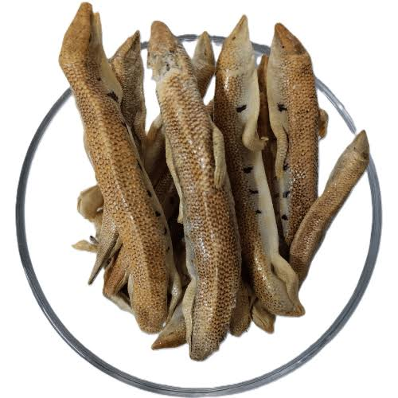

Safed Musli (Chlorophytum borivilianum)
Rs 100/ 10g
Brand: —
Size: —
Use: Thin white-yellow tuberous roots; a well-known Ayurvedic/Unani general vitality and stamina tonic.
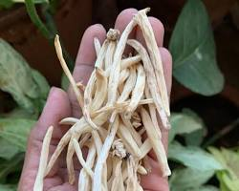

Ashwagandha (Indian Ginseng Root)
Rs 20/ 10g
Brand: —
Size: —
Use: Withania somnifera root; a classical adaptogen used to support stamina, stress resilience, and vitality.
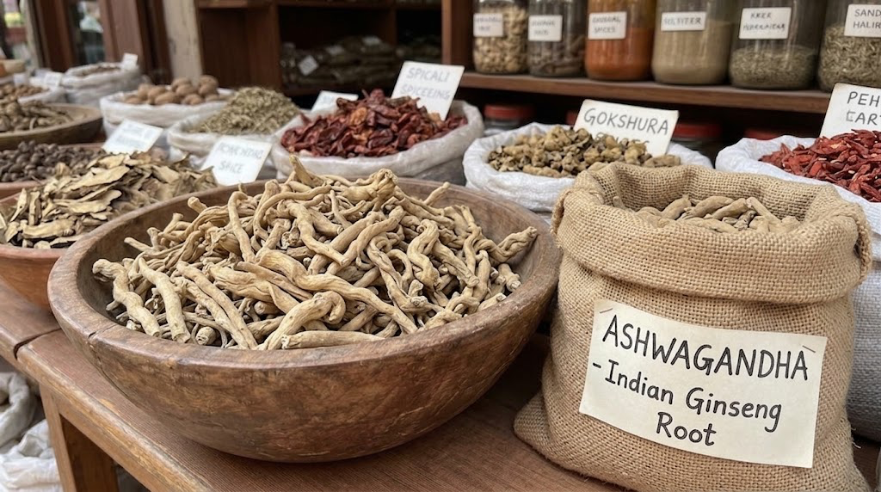

Akar Karan (Pellitory Root)
Rs 150 / 10g
Brand: —
Size: —
Use: Dried pellitory root; traditionally used for dental/oral health and as a warming digestive herb.
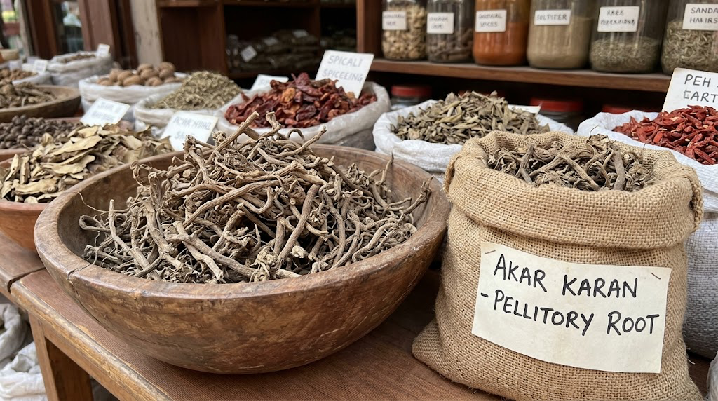

Skin Care
Multani Mitti (Fuller's Earth)
Rs 250/ kg
Brand: —
Size: —
Use: Natural clay used as a traditional face and skin pack; helps absorb excess oil and cleanse the skin.
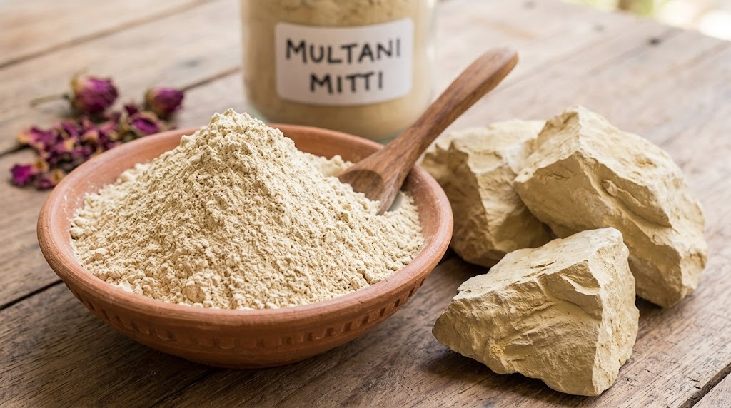

Hair Color
Black Henna (Herbal Hair Colour)
Rs 100/ 250g
Brand: —
Size: —
Use: 100% pure and natural herbal henna paste/powder used to color and condition hair and for body art.
